Guns, Germs, and Steel Episode 2; Conquest

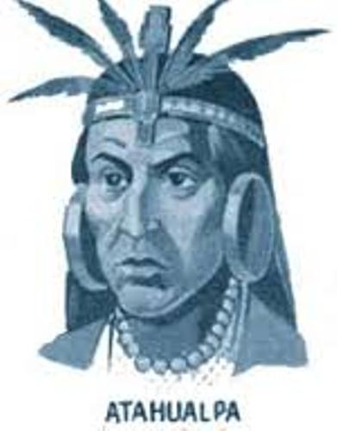
- Describe the weaponry that the Spanish conquistadors had as they invaded the Inca Empire.

- Who was the leader of the conquistadores? What were they searching for?

- Contrast the use of farm animals in Europe with the use of animals in the New World. What consequences did this have for both societies?

- How did horses help the Spanish?

- What was Atahualpa’s attitude toward the conquistadores? What was his plan for them?

- What was the Conquistadors impression of the Inca camp?

- What is Jared Diamond’s explanation for why the Spanish had advanced to steel swords while the Inca’s were still making tools and weapons from bronze?

- How did the battle tactics used by the Spanish conquistadors help the small army defeat the Inca army that outnumbered it by the thousands?

