Haitian Revolution Poster Project
Directions: Students will be producing a poster from the perspective of one of the factions fighting in the Haitian Revolution: Napoleon, the Haitian Rebels, or Sonthonax’s faction. Students will be producing a propaganda poster which argues the virtue of your faction, the wickedness of your enemies, and the goals of your movement.

Poster should include the following:
- It should be clear which faction your poster represents.
- Your poster should demonstrate what your faction’s goal is.
- Your poster should attack the opposition and/or their goals in some way.
- Some type of imagery that will strengthen your argument.
- As always, I am easily charmed by something clever. Be clever and get extra points and my affection.

Haitian Revolution Poster Rubric

CATEGORY | 4 | 3 | 2 | 1
Use of Class Time | Used time well during each class period. Focused on getting the project done. Never distracted others. | Used time well during each class period. Usually focused on getting the project done and never distracted others. | Used some of the time well during each class period. There was some focus on getting the project done but occasionally distracted others. | Did not use class time to focus on the project OR often distracted others.
Graphics – Originality | Several elements on the poster that reflect an exceptional degree of student creativity in their creation and/or display. | One or two elements on the poster reflecting student creativity in their creation and/or display. | The poster has been created by the students, but is based on the designs or ideas of others. | No elements of the poster have been created by the students.
Required Elements | The poster includes all required elements as well as additional information. | All required elements are included on the poster. | All but 1 of the required elements are included on the poster. | Several required elements were missing.
Grammar/ Spelling | There are no grammatical mistakes or spelling errors on the poster. | There is 1 grammatical mistake or spelling error on the poster. | There are 2 grammatical mistakes or spelling errors on the poster. | There are more than 2 grammatical mistakes or spelling errors on the poster.
Labels | All items of importance on the poster are clearly labeled with labels that can be read from at least 3 feet away. | Almost all items of importance on the poster are clearly labeled with labels that can be read from at least 3 feet away. | Several items of importance on the poster are clearly labeled with labels that can be read from at least 3 feet away. | Labels are too small to view OR no important items were labeled.

Example Propaganda

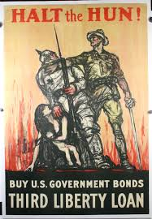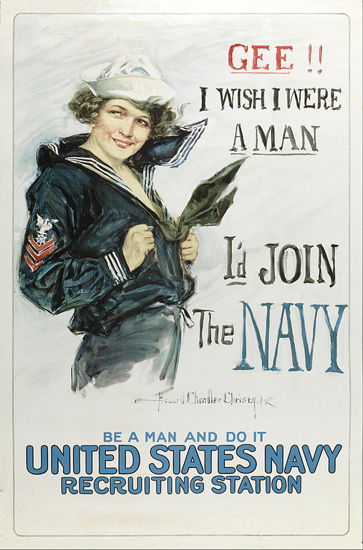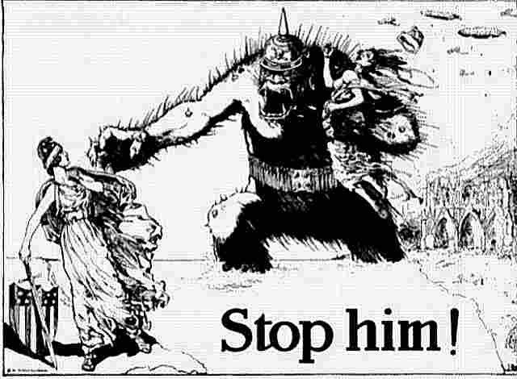

Haitian Revolution (1791-1804)

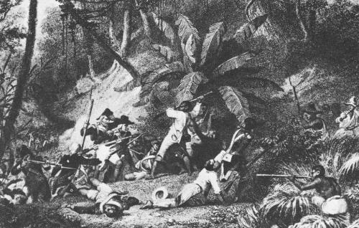
Image Ownership: Public Domain
The Haitian Revolution has often been described as the largest and most successful slave rebellion in the Western Hemisphere. Slaves initiated the rebellion in 1791 and by 1803 they had succeeded in ending not just slavery but French control over the colony. The Haitian Revolution, however, was much more complex, consisting of several revolutions going on simultaneously. These revolutions were influenced by the French Revolution of 1789, which would come to represent a new concept of human rights, universal citizenship, and participation in government.
In the 18th century, Saint Dominigue, as Haiti was then known, became France's wealthiest overseas colony, largely because of its production of sugar, coffee, indigo, and cotton generated by an enslaved labor force. When the French Revolution broke out in 1789 there were five distinct sets of interest groups in the colony. There were white planters—who owned the plantations and the slaves—and petit blancs, who were artisans, shop keepers and teachers. Some of them also owned a few slaves. Together they numbered 40,000 of the colony’s residents. Many of the whites on Saint Dominigue began to support an independence movement that began when France imposed steep tariffs on the items imported into the colony. The planters were extremely disenchanted with France because they were forbidden to trade with any other nation. Furthermore, the white population of Saint-Dominique did not have any representation in France. Despite their calls for independence, both the planters and petit blancs remained committed to the institution of slavery.
The three remaining groups were of African descent: those who were free, those who were slaves, and those who had run away. There were about 30,000 free black people in 1789. Half of them were mulatto and often they were wealthier than the petit blancs. The slave population was close to 500,000. The runaway slaves were called maroons; they had retreated deep into the mountains of Saint Dominigue and lived off subsistence farming. Haiti had a history of slave rebellions; the slaves were never willing to submit to their status and with their strength in numbers (10 to 1) colonial officials and planters did all that was possible to control them. Despite the harshness and cruelty of Saint Dominigue slavery, there were slave rebellions before 1791. One plot involved the poisoning of masters.
Inspired by events in France, a number of Haitian-born revolutionary movements emerged simultaneously. They used as their inspiration the French Revolution’s “Declaration of the Rights of Man.” The General Assembly in Paris responded by enacting legislation which gave the various colonies some autonomy at the local level. The legislation, which called for “all local proprietors...to be active citizens,” was both ambiguous and radical. It was interpreted in Saint Dominigue as applying only to the planter class and thus excluded petit blancs from government. Yet it allowed free citizens of color who were substantial property owners to participate. This legislation, promulgated in Paris to keep Saint Dominigue in the colonial empire, instead generated a three-sided civil war between the planters, free blacks and the petit blancs. However, all three groups would be challenged by the enslaved black majority which was also influenced and inspired by events in France.
Led by former slave Toussaint l’Overture, the enslaved would act first, rebelling against the planters on August 21, 1791. By 1792 they controlled a third of the island. Despite reinforcements from France, the area of the colony held by the rebels grew as did the violence on both sides. Before the fighting ended 100,000 of the 500,000 blacks and 24,000 of the 40,000 whites were killed. Nonetheless the former slaves managed to stave off both the French forces and the British who arrived in 1793 to conquer the colony, and who withdrew in 1798 after a series of defeats by l’Overture’s forces. By 1801 l’Overture expanded the revolution beyond Haiti, conquering the neighboring Spanish colony of Santo Domingo (present-day Dominican Republic). He abolished slavery in the Spanish-speaking colony and declared himself Governor-General for life over the entire island of Hispaniola.
At that moment the Haitian Revolution had outlasted the French Revolution which had been its inspiration. Napoleon Bonaparte, now the ruler of France, dispatched General Charles Leclerc, his brother-in-law, and 43,000 French troops to capture L’Overture and restore both French rule and slavery. L’Overture was taken and sent to France where he died in prison in 1803. Jean-Jacques Dessalines, one of l’Overture’s generals and himself a former slave, led the revolutionaries at the Battle of Vertieres on November 18, 1803 where the French forces were defeated. On January 1, 1804, Dessalines declared the nation independent and renamed it Haiti. France became the first nation to recognize its independence. Haiti thus emerged as the first black republic in the world, and the second nation in the western hemisphere (after the United States) to win its independence from a European power.

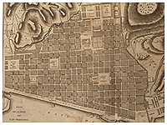
At the outbreak of the French Revolution in 1789, the colony of St. Domingue, now Haiti, furnished two-thirds of France’s overseas trade, employed one thousand ships and fifteen thousand French sailors. The colony became France’s richest, the envy of every other European nation. This plantation system, which provided such a pivotal role in the French economy, was also the greatest individual market for the African slave trade. Yet, conflict and resentment permeated the society of San Domingo, and slave resistance began to take an organized form in the late 18th century. The French Revolution did inspire many in 1789, but black resistance had existed for years. In August of 1791 an organized slave rebellion broke out, marking the start of a twelve-year resistance to obtain human rights. The Haitian Revolution is the only successful slave revolt in history, and resulted in the establishment of Haiti, the first independent black state in the New World.
One must emphasize the struggles that had been occurring for decades prior to the 1791 outbreak of full-scale rebellion. Yet the French Revolution was also crucially important, for the conflicts between whites about what exactly its ideals meant triggered an opportunity for blacks. A historically significant step was the issuance of the Declaration of Rights of Man passed in France on August 26, 1789. It stated, "In the eyes of the law all citizens are equal." While the French government did not want to release this to their colonies, word got out. News of the Declaration of Rights of Man brought new hopes to the black masses. Meanwhile, plantation owners and the French government continued to exploit the slaves for profit.
A series of revolts occurred in 1790, by mulattoes led by Vincent Ogé. Descendents of mixed blood were trying to establish suffrage from a recent National Assembly ruling. However the white Colonial Assembly ignored French efforts. These mulatto-led revolts were the first challenges against French rule and the slaveholding system. In August of 1791, the first organized black rebellion ignited the twelve-year San Domingo Revolution. The northern settlements were hit first, and the flood that overwhelmed them revealed the military strength and organization of the black masses. Plantations were destroyed, and white owners killed to escape the oppression. Some of the rebellion’s leaders include Boukman, Biassou, Toussaint, Jeannot, Francois, Dessalines, and Cristophe. These men would help to guide the Revolution down its torturous, bloody road to complete success, although it would cost over twelve years and hundreds of thousands of lives. Many of those leaders themselves would fall along the way, but the force of unity against slavery, a unity deeply embedded in the creole culture that bound the blacks together, would sustain the revolution.
After the revolutionaries’ initial successes in overwhelming the institution of plantation slavery on the Plaine du Nord, Le Cap fell into the hands of French republican forces. Toussaint and thousands of blacks joined them in April 1793. The agreement was if the blacks fought against the royalists, the French would promise freedom. Thus, on August 29, 1793, Commissioner Légér-Felicité Sonthonax abolished slavery in the colony. Then with self-interest in mind, revolutionary France’s British enemies tried to seize an opportunity to grab the colony, so recently the greatest single source of colonial wealth in the whole world. Furthermore, the British wanted to put down the slave rebellion in order to protect their own slave colonies.
In June of 1794 British forces landed on the island and worked with Spain to attack the French. Yet, the British forces soon fell victim to yellow fever. With more uncertainties presenting themselves, Toussaint decided to pledge his support to the French, on May 6, 1794. Toussaint was appointed governor in 1796 and he continued to follow his ideas for an autonomous black- led San Domingo. By January 1802, Toussaint was the head of a semi-independent San Domingo. Napoleon saw this as a threat and sent his brother-in-law Victor-Emmanuel Leclerc from France with 20,000 troops to capture Toussaint, and re-establish slavery in the colony. Toussaint was deceived in 1802, captured and shipped to France, where he eventually died in prison.
But the struggle for independence continued and by late 1803 the north and south arenas of the island united and defeated the French under Rochambeau. Dessalines, Toussaint’s former lieutenant proclaimed the independence of the country of Haiti and declared himself Emperor. He was assassinated in 1806, and the country divided between rival successors. Yet, the rebels had shattered the enslaved colony and forged from the ruins the free nation of Haiti.

Napoleon and Haiti

1801-1805: Napoleon makes an attempt to retake the Caribbean, and blacks make history
In Europe, Napoleon Bonaparte came to power and ended the French Revolution. However, in the Caribbean, Hispaniola in particular, the residents had their own ideas of who should lead.

Reconquering the West
Napoleon's goal was to re-establish the former French empire and bring France back to glory. The 1801 Peace of Amiens ended the fighting with Britain, and Britain returned all the French territories in the Caribbean except Trinidad. Meanwhile, Spain returned Louisiana to the French in the same year.
Napoleon hoped to annex Florida and French Guiana in this group as well, but he needed French Hispaniola to continue his plans, and he sent his brother-in-law, General Charles Leclerc, to secure the island.

Attacks on the Island
Leclerc met with the same defeat the British had faced earlier, despite the regiment of 20,000 soldiers as well as conscripts from other nations. In 1802 and 1803, Napoleon lost 40,000 men and turned the war on Hispaniola to a racial war.
Leclerc began by dominating the coastal strongholds and shortly began an attack on the interior, but all of his victories were costly. Still, tropical diseases had yet to take their toll, and nearly half the soldiers came down with or died of yellow fever.
Toussaint L'Overture was abducted in 1803 from a dinner invitation with Leclerc after his surrender, and he died in France that year. Leclerc's victory was short-lived, as yellow fever decimated nearly all of his solders. Leclerc was forced to defer to Toussaint's right-hand men, Jean-Jacques Dessalines and Henri Christophe.

Breaking Trust
During these years, slavery had been re-established on Guadeloupe and Martinique, and Leclerc moved to reinstate slavery on Hispaniola. He lost the trust of mulattoes and blacks, and many rebelled, but the men who had deserted Toussaint for Leclerc turned against Leclerc.
Dessalines and Christophe quickly took back lands from Leclerc, and Dessalines became the leader of the resistance at the end of 1802. Leclerc himself died of yellow fever at this time, leaving General Rochambeau as his replacement. Another 25,000 troops arrived as reinforcements, and he continued brutal attacks.

War Again
In 1803, Britain again fought France, and forces reclaimed St. Lucia, Martinique, and Guadeloupe before blockading Hispaniola. By the end of 1803, the remaining French left with 18,000 refugees as the British bombarded the coast.
The end to this devastation came in January of 1804, when Dessalines and his generals declared the independent state of Haiti. They chose the Arawak word for the island, which meant "the land of the mountains." Dessalines spent the rest of his life as governor-general, even being crowned emperor in 1805 in imitation of Napoleon, but he died in an uprising the following year.
The Napoleonic Wars ended in 1815, though most believe that Spain, not France, suffered the biggest losses during the wars. France occupied Spain from 1808-1812, allowing the Creole leaders to take control in the Caribbean and the Americas. It was at the end of this war, however, that France finally recognized the colony of Haiti as its own country.
Haiti's precarious history has continued to this day. The blacks on Hispaniola had gotten a taste of a free world, and they fought to keep it that way, but the European interest was continuously troublesome.

Napoleon and French Reaction

“My decision to destroy the authority of the blacks in Saint Dominque (Haiti) is not so much based on considerations of commerce and money, as on the need to block for ever the march of the blacks in the world.”
— Napoleon Bonaparte

L'Ouverture, Toussaint (1742-1803)

Back to Online Encyclopedia Index
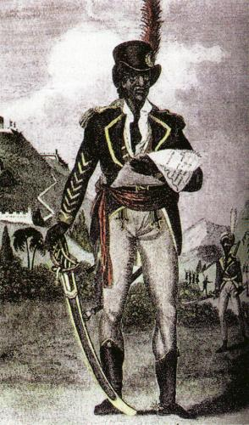
Known to his contemporaries as “The Black Napoleon,” Toussaint L’Ouverture was a former slave who rose to become the leader of the only successful slave revolt in modern history, the Haitian Revolution.
Born into slavery on May 20, 1743 in the French colony of Saint Dominque, L’Ouverture was the eldest son of Gaou Guinon, an African prince who was captured by slavers. At a time when revisions to the French Code Noir (Black Code) legalized the harsh treatment of slaves as property, young L’ Overture instead inspired kindness from those in authority over him. His godfather, the priest Simon Baptiste, for example, taught him to read and write. Impressed by L’Ouverture, Bayon de Libertad, the manager of the Breda plantation on which L’Ouverture was born, allowed him unlimited access to his personal library. By the time he was twenty, the well-read and tri-lingual L’Ouverture—he spoke French, Creole, and some Latin—had also gained a reputation as a skilled horseman and for his knowledge of medicinal plants and herbs. More importantly, L’Ouverture had secured his freedom from de Libertad even as he continued to manage his former owner’s household personnel and to act as his coachman. Over the course of the next 18 years, L’Ouverture settled into life on the Breda plantation marrying fellow Catholic Suzanne Simon and parenting two sons, Isaac and Saint-Jean.
The events of August 22, 1791, the “Night of Fire” in which slaves revolted by setting fire to plantation houses and fields and killing whites, convinced the 48-year-old L’Ouverture that he should join the growing insurgency, although not before securing the safety of his wife and children in the Spanish-controlled eastern half of the island (Santo Domingo) and assuring that Bayon de Libertad and his wife were safely onboard a ship bound for the United States.
Inspired by French Revolutionary ideology and angered by generations of abuse at the hands of white planters, the initial slave uprising was quelled within several days, but ongoing fighting between the slaves, free blacks, and planters continued. Although he was free, L’Ouverture joined the slave insurgency and quickly developed a reputation first as a capable soldier and then as military secretary to Georges Biassou, one of the insurgency’s leaders. When the insurgency’s leadership chose to ally itself with Spain against France, L’Ouverture followed. Threatened by Spain and Britain’s attempts to control the island, the French National Convention acted to preserve its colonial rule in 1794 by securing the loyalty of the black population; France granted citizenship rights and freedom to all blacks within the empire.
Following France’s decision to emancipate the slaves, L’Ouverture allied with France against Spain, and from 1794 to 1802, he was the dominant political and military leader in the French colony. Operating under the self-assumed title of General-in-Chief of the Army, L’Ouverture led the French in ousting the British and then in capturing the Spanish controlled half of the island. By 1801, although Saint Dominque remained ostensibly a French colony, L’Ouverture was ruling it as an independent state. He drafted a constitution in which he reiterated the 1794 abolition of slavery and appointed himself governor for “the rest of his glorious life.”
L’Ouverture’s actions eventually aroused the ire of Napoleon Bonaparte. In 1802 Napoleon dispatched his brother-in-law, Charles Leclerc, to capture L’Ouverture and return the island to slavery under French control. Captured and imprisoned at Fort de Joux in France, L’Ouverture died of pneumonia on April 7, 1803. Independence for Saint Dominque would follow one year later under the leadership of Jean-Jacques Dessalines, one of L’Ouverture’s generals.

Léger-Félicité Sonthonax
From Wikipedia, the free encyclopedia
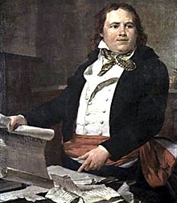
Late 18th-century oil-painting portrait of Sonthonax
Léger-Félicité Sonthonax (1763–1813) was a French Girondist and abolitionist during the French Revolution who controlled 7,000 French troops in Saint-Domingue during part of the Haitian Revolution.^{[1]} His official title was Civil Commissioner. From September 1792 to December 1795 he was the de facto ruler of Saint-Domingue's non-slave populace. Within a year of his appointment his powers were considerably expanded by the Committee of Public Safety. He was recalled in 1795 largely due to the resurgence of conservative politics in France. Sonthonax believed that Saint-Domingue's whites were royalists or separatists and therefore he attacked the military power of the white settlers and by doing so alienated the colonial settlers from their government. Many gens de couleur (mixed-race residents of the colony) asserted that they could form the military backbone of Saint-Domingue if they were given rights, but Sonthonax rejected this view as outdated in the wake of the August 1791 slave uprising. He believed that Saint-Domingue would need ex-slave soldiers among the ranks of the colonial army if it was to survive. Although he did not originally intend to free the slaves, by August 1793 he was forced into ending slavery in order to maintain his own power.^{[2]}

