Mountains of Silver: Tiny Bolivian village of Potosi was once the largest industrial mining complex in the world

Empires may rise and fall, but the impact they have on their conquered subjects and the future may continue beyond their passing, for better or for worse. The Spanish Empire, which began in the 15th century with the colonization of the Americas, and lasted till the 19th century, left its own mark on its colonies. One of the more tragic legacies of the Spanish Empire is the exploitation of the native population and resources. One such place where this can be seen is the city of Potosí.

Potosí is located in present day Bolivia. Located at an altitude of over 4,000 meters (13,000 feet) above sea level, Potosí is one of the highest cities in the world. Prior to the arrival of the Spanish, Potosí was just a small village in the Andes. Between 1542 and 1545, however, the biggest silver lodes in the New World were discovered in the Cerro de Potosí (known also as the Cerro Rico, meaning ‘Rich Mountain’), a mountain located just to the south of the city.

The discovery resulted in the transformation of this tiny village into the largest industrial complex of the 16th century.
Spain grew immensely wealthy from the Potosí’s silver mines. In the 1520s, silver that was obtained from Spain’s American colonies weighed at 148 kilograms (326 pounds) per year. By the 1590s nearly three million kilograms of silver (6.6 million pounds) sailed across the Atlantic annually from the New World to Spain.

Using a series of hydraulic mills, silver ore was mined from the mountain. The silver was then extracted from the ore through amalgamation with mercury, known also as the patio process. The extracted silver was then molded into bars (or coins known as ‘pieces of eight’ after 1598) and stamped with the mark of the Royal Mint. From Potosí, the silver travelled across the Andes on llamas to Lima and the Pacific coast, after which it was taken by the Spanish treasure fleets from Peru up to Panama. After an overland journey across the isthmus, the silver from Potosí finally crossed the Atlantic to Spain.
Silver from Potosí made Spain’s monarchs the wealthiest and most powerful rulers in Europe. It allowed them to fund their armies, and pursue military expansion. With the silver from Potosí, Spain was able to wage war against the English, Dutch, French and Ottoman Turks. Yet, the circulation of Spanish silver was not limited to Europe. In the form of pieces of eight, Spanish silver also travelled all the way to Asia, as the Spanish were in control of the Philippines. The influx of Spanish silver in Asia destabilized the economies of East Asian countries, and even caused financial chaos in Ming China.
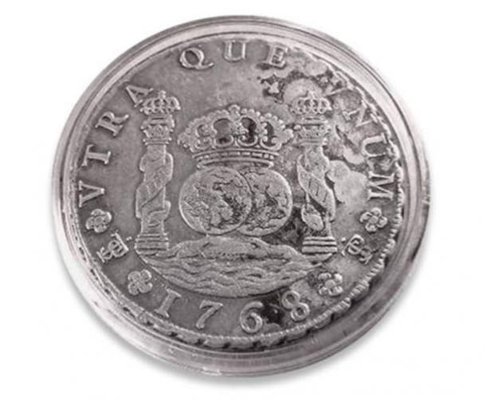
Coin minted from the silver of Potosi, 1768. Public Domain

The price of Spain’s wealth was paid for with the lives of indigenous South American and African slaves who worked in the mines. On average, these miners worked for 6 months, before dying from mining accidents, lung related diseases, starvation or exhaustion. It has been estimated that over the course of nearly 300 years of Spanish rule in Potosí, as many as eight million miners perished in order to fill the coffers of the Spanish Empire.

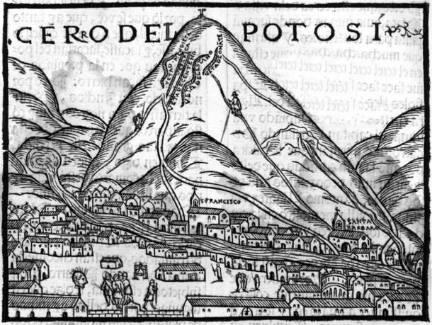
Potosi, the first image in Europe. Pedro Cieza de León, 1553. Public Domain

The end of Spanish rule in Bolivia in 1825 did not mark the end of the Potosí mines. While the silver veins were almost exhausted by then, resulting in the closure of many mines, there were other metals to be mined. Due to the Industrial Revolution in Europe, tin became a valuable commodity, and was mined in Potosí. Today, zinc is the primary product of the mines. Despite advances in mining technology, nothing much has changed in the way minerals are extracted in Potosí since the arrival of the Spanish. Mining in Potosí today is still an extremely hazardous job, not only to the thousands of miners, but to the surrounding environment as well. This is the harsh legacy left behind by the Spanish Empire on the city of Potosí.

