The Chinese Silver Trade
- Between 1500 and 1800, what percentage of the world’s silver trade did Mexico and Peru produce?

- Where was over 40% of that silver going?

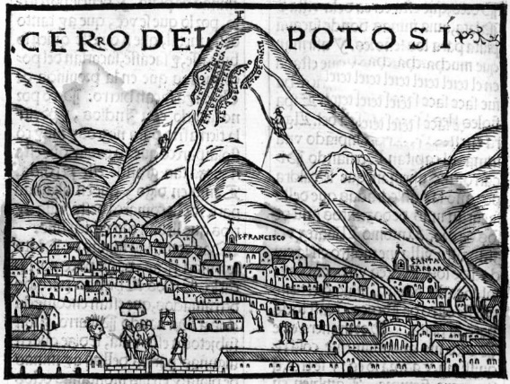
- What were Europeans trading silver for?

- What were the Chinese using this silver for?

- Which dynasty developed the world’s first paper money?

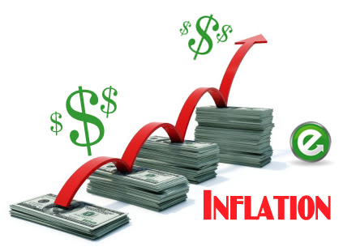
- What was paper money “only as good as?”

- How did the Yuan and Ming undermine paper money?

- What did Europeans want to hoard silver for?

- What did Europeans eventually use to replace the silver trade to China with?

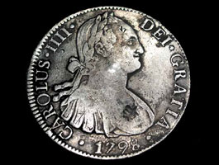
- What did the Chinese name the Silver coin with the bust of Carlos IV? What happened to the price of this coin?

- Why were the Dutch making coins with the face of a dead Spanish king?

- What effect did the silver trade have on the world?

- Why were few good traded over long distance in pre-industrial times?

- Why were American crops were important to Chinese agriculture in the eighteenth century?

